Task 5
Develop two UML Activity Diagrams for two major business processes. [2 marks]
Diagram 1: Student Activity Registration & Waitlist Handling
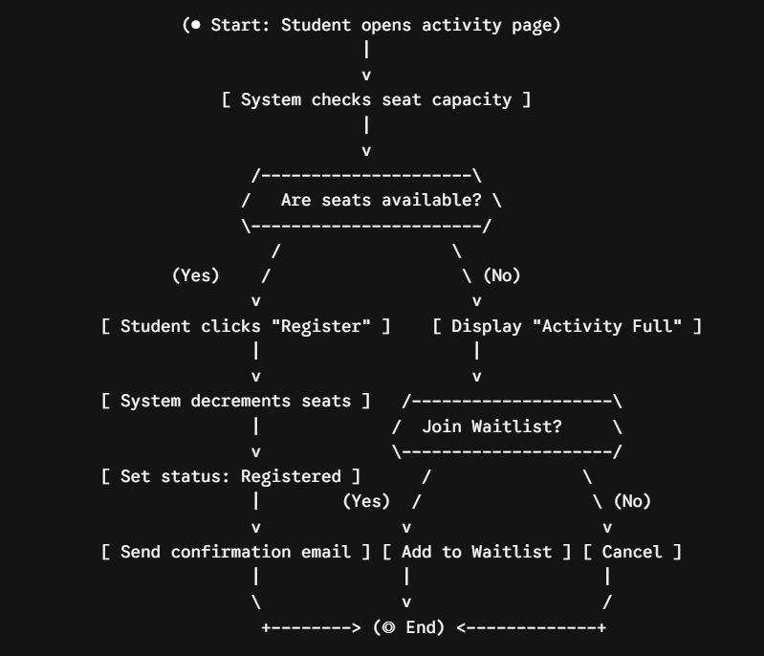

Diagram 2: QR Code Attendance Verification & Transcript Update

